OVERVIEW
This poster project will be worth 5% of extra credit added to the total course grade and is designed to help familiarize students with various ideas in Physics 14 topics. As a group of either 2 students, you will collectively construct a poster about a pre-selected topic in Physics 14. Each student will sign up for a single topic from a given list. Each person in the group must contribute equally to the construction of the poster and the material it contains. If a student doesn’t contribute to the poster project, as indicated by his/her fellow project partners, then the student will be moved to another group OR receive a zero for the project.

CONTENTS
The poster itself must be a Trifold presentation board with a minimum size of dimensions 22" by 28". The poster can be of any color, as seen below in FIGURE 1.
The poster project must contain the following sections: abstract, pictures, main ideas, and a references section. Visual or physical props are encouraged but not required or graded.

- The abstract is a summary of your chosen topic and must concisely explain your poster in 5-7 sentences. Make sure to use appropriate diction and correct grammar.

- In order to support the main ideas of your poster you'll need to include at least three pictures about your topic. The pictures may be either hand-drawn or computer generated. If you take pictures from the internet, or any online source, make sure to properly cite them in your references section. You should have 1-2 sentences summarizing (i.e., explaining) each and every picture present in the poster. This caption should be located directly below (or above) each and every picture.

- The main ideas section of your poster will contain the factual information about the chosen topic. These ideas should take the form of between 2 and 4 short paragraphs (with 3-5 sentences for each paragraph). For the factual information about your chosen topic you may use your textbook, other physics textbooks, and any credible online resources. However, make sure to properly cite your sources for the references section of your poster.
- The references section of your poster will act similar to a bibliography. List and include all the resources that you used in presenting material shown on your poster. There is a minimum at of least 4 sources to be used for this project, with a maximum of 7 resources. Only 2 of your sources can be from the Internet, and 1 of your sources can be the class textbook. This section should be placed in the lower right hand portion of your poster itself. Make the font size no smaller than 14 and no larger than 22. For an example of how to properly cite resources in the references section you may go to:

http://www.aresearchguide.com/12biblio.html

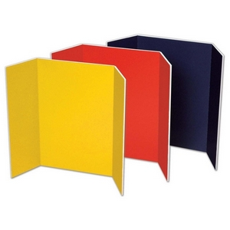
FIGURE 1
Here are a few examples of the type of poster required for this project. These may be purchased at various retailers such as Walgreens, Staples, Walmart, Office Depot, etc.

Above all else be artistic in the presentation of your given topic. Make your poster a "feast for the eyes" so that people will flock towards it. Now Attack!

